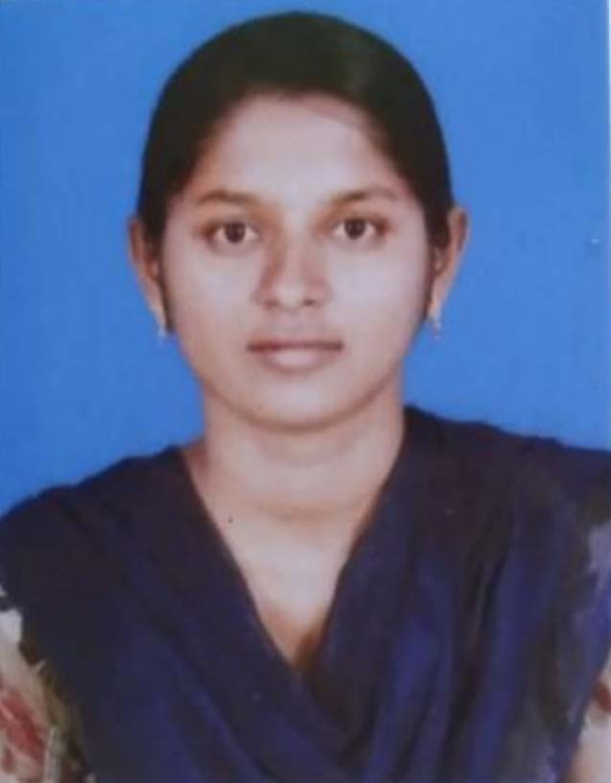KAVYA SIVAKUMAR
Email-id : sivakavya152@gmail.com Mobile No : 9363021824
- - - - - - - - - - - - - - - - - - - - - - - - - - - - - - - - - - - - - - - - - - - - - - - - - - - - - - - - - - - - - - - - - - - -

CAREER OBJECTIVE
Seeking challenging environments that encourage continuous learning and creativity providing exposure to new ideas that stimulate professional and personal growth.
- - - - - - - - - - - - - - - - - - - - - - - - - - - - - - - - - - - - - - - - - - - - - - - - - - - - - - - - - - - - - - - - - - - -

EDUCATIONAL QUALIFICATION

Course | Institution | University  /Board | Year of passing | Percentage
BCA | Muthayammal Memorial College of Arts and  Science,Kakkaveri | Periyar University | 2022  Doing | 78%  (upto 5th sem)
HSC | Sri Vidya Mandir Matric  Hr.Sec.School, Rasipuram | State Board | 2019 | 58.75%
SSLC | Kalaimagal Matriculation  Hr.Sec. School,Belukurichi | State Board | 2017 | 77.8%

- - - - - - - - - - - - - - - - - - - - - - - - - - - - - - - - - - - - - - - - - - - - - - - - - - - - - - - - - - - - - - - - - - - -

TECHINICAL SKILLS
- PROGRAMMING LANGUAGE : C ++, JAVASCRIP
- SCRIPTING & MARKUP LANGUAGE : HTML
- PACKAGE : MS Office
- - - - - - - - - - - - - - - - - - - - - - - - - - - - - - - - - - - - - - - - - - - - - - - - - - - - - - - - - - - - - - - - - - - -

PERSONAL TRAITS
- Motivating & goal oriented
- Easily adoptable to environment
- Self Learner

EXTRA CURRICULAR ACTIVITES
- Dancing
- Drawing
- Kho Kho
- Kabaddi

- - - - - - - - - - - - - - - - - - - - - - - - - - - - - - - - - - - - - - - - - - - - - - - - - - - - - - - - - - - -

PEERSONAL DETAILS
Father Name : Mr.R.Sivakumar
Mother Name : Mrs .S .Radha
Gender : Female
Age 20
Date of Birth : 25.10.2001
Nationality : Indian
Religion : Hindu
Blood Group : B+ve
Address : Palaniyappanur Post, Rasipuram Taluk, Namakkal Dist, Tamilnadu, (637406) India.

- - - - - - - - - - - - - - - - - - - - - - - - - - - - - - - - - - - - - - - - - - - - - - - - - - - - - - - - - - - -

DECLARATION

I hereby declare that the given about are true to the best of my
knowledge.

Date : With regards,
Place : ( KAVYA SIVAKUMAR)

